# CS 255 System Design Document

*Prepared by James Polley*

*August 14, 2022*

## UML Diagrams

### UML Use Case Diagram

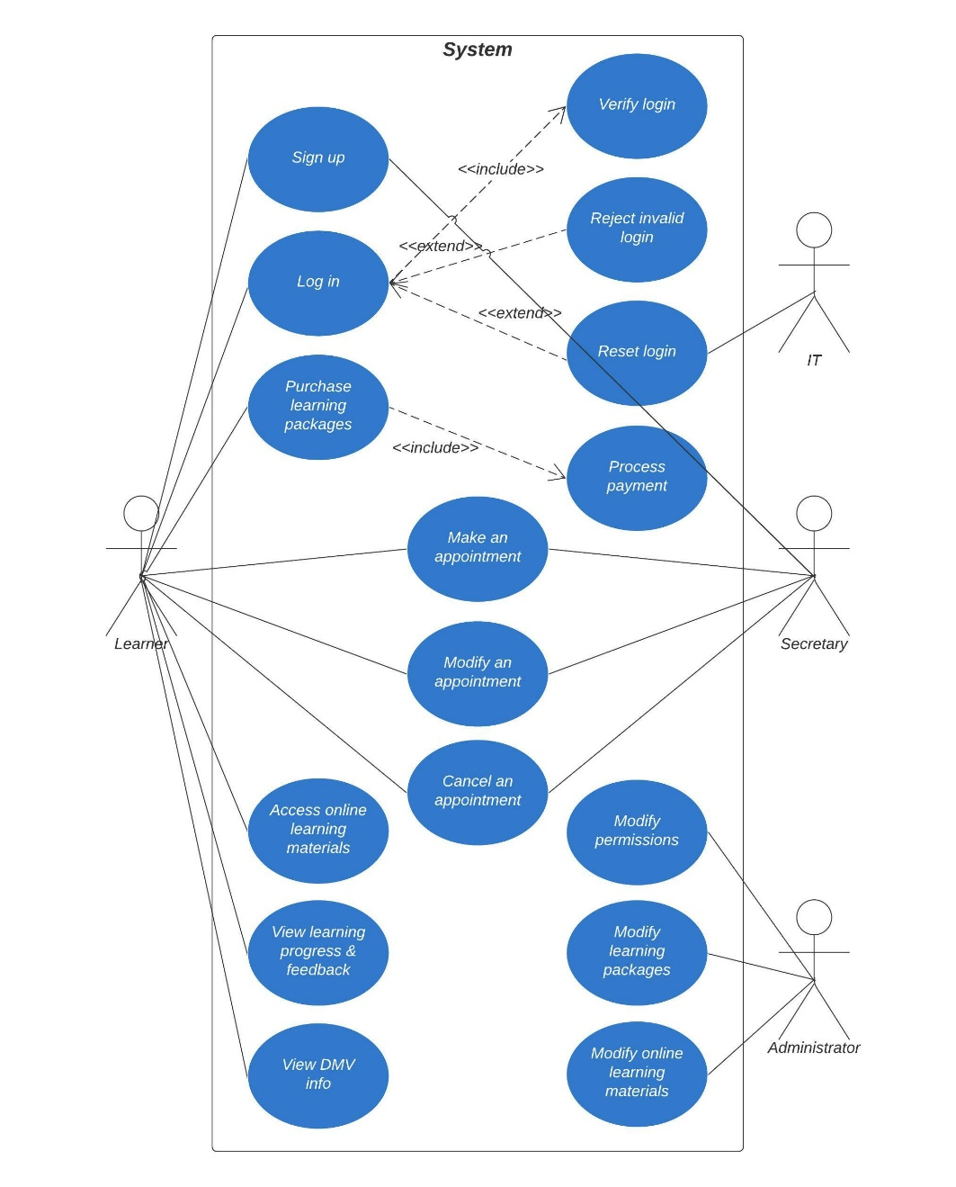

### UML Activity Diagrams

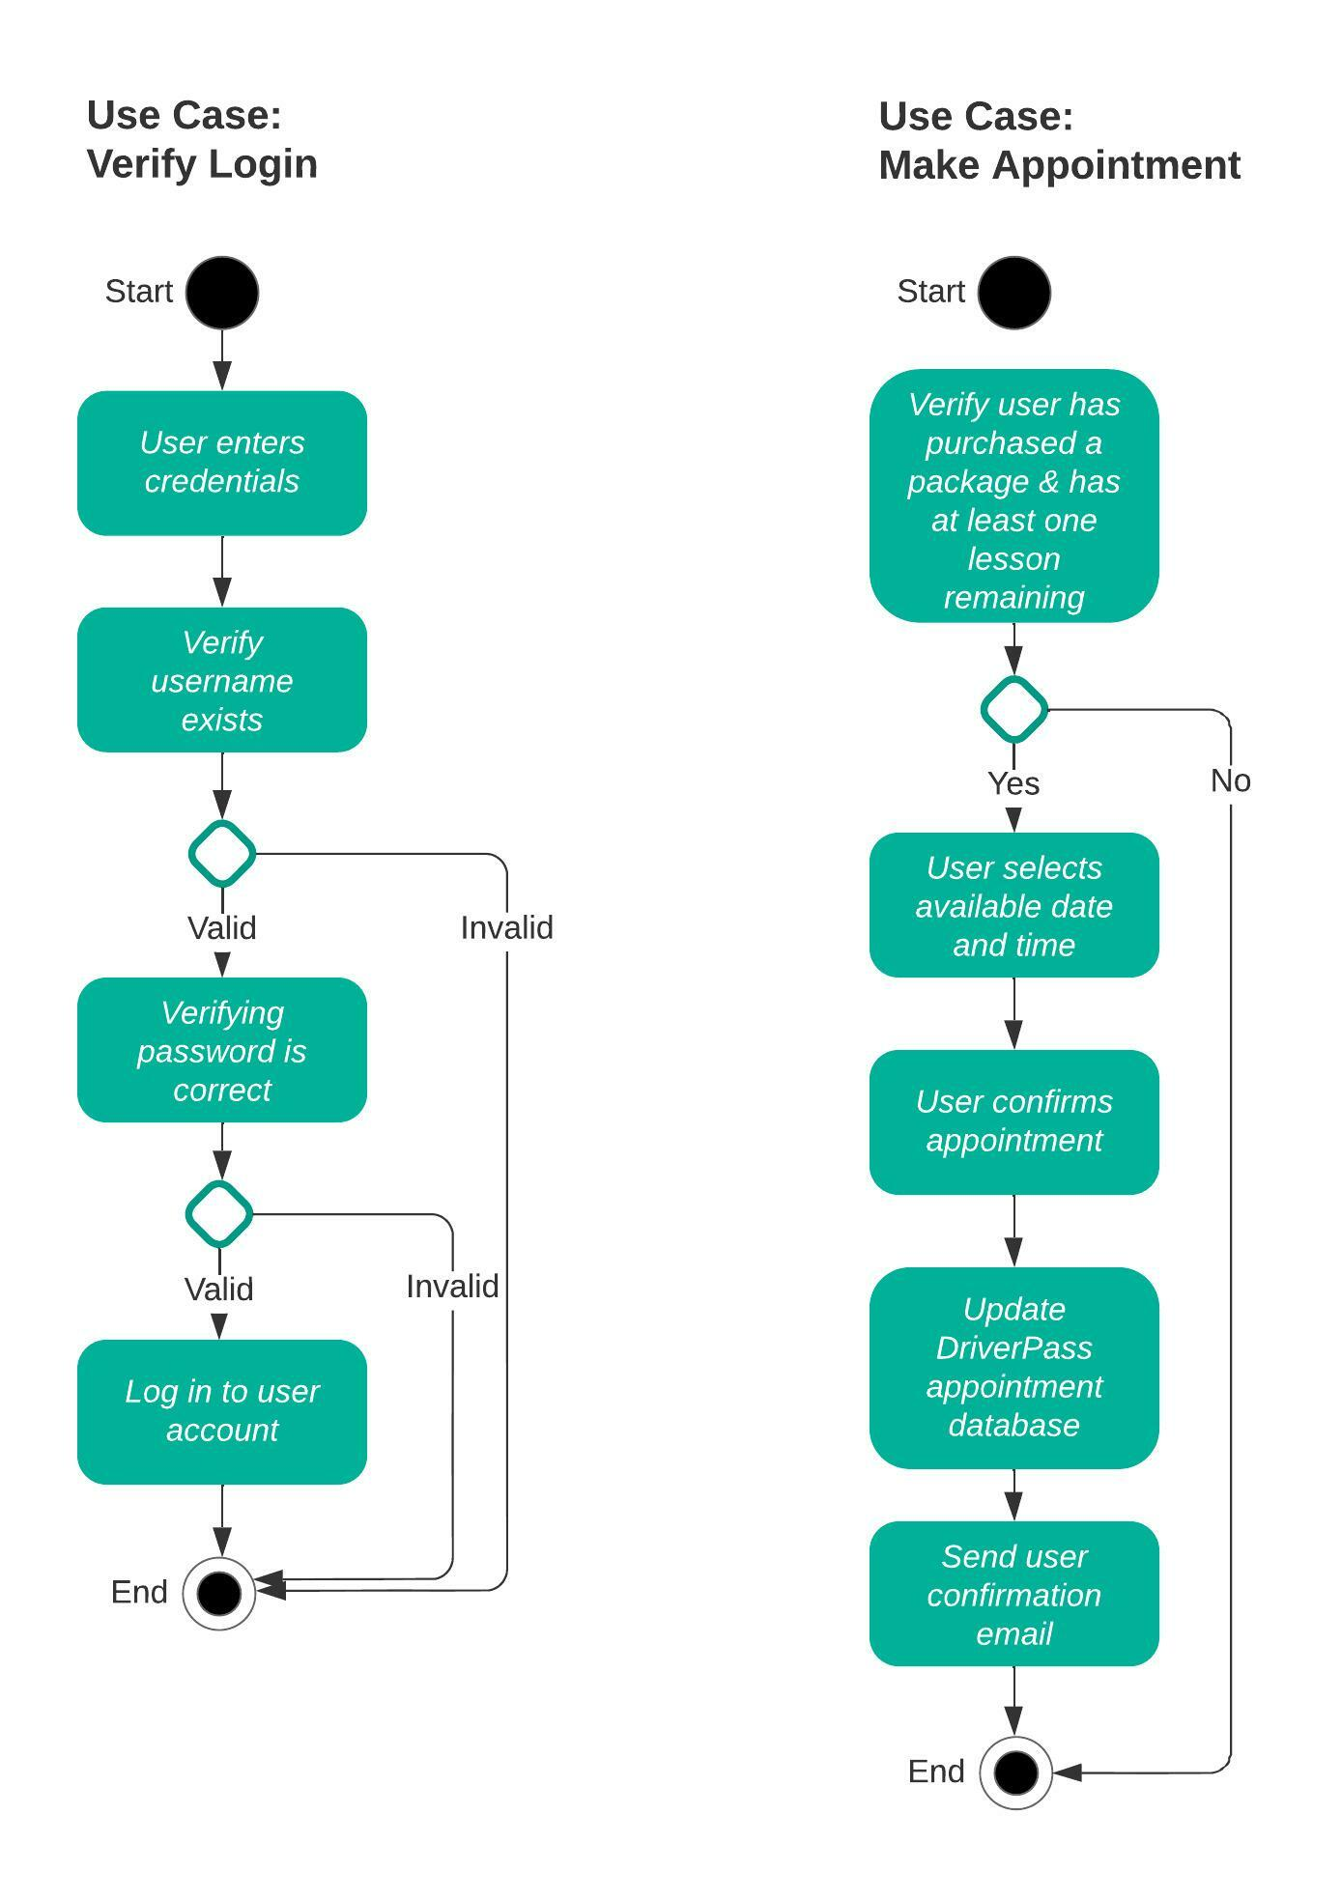

### UML Sequence Diagram

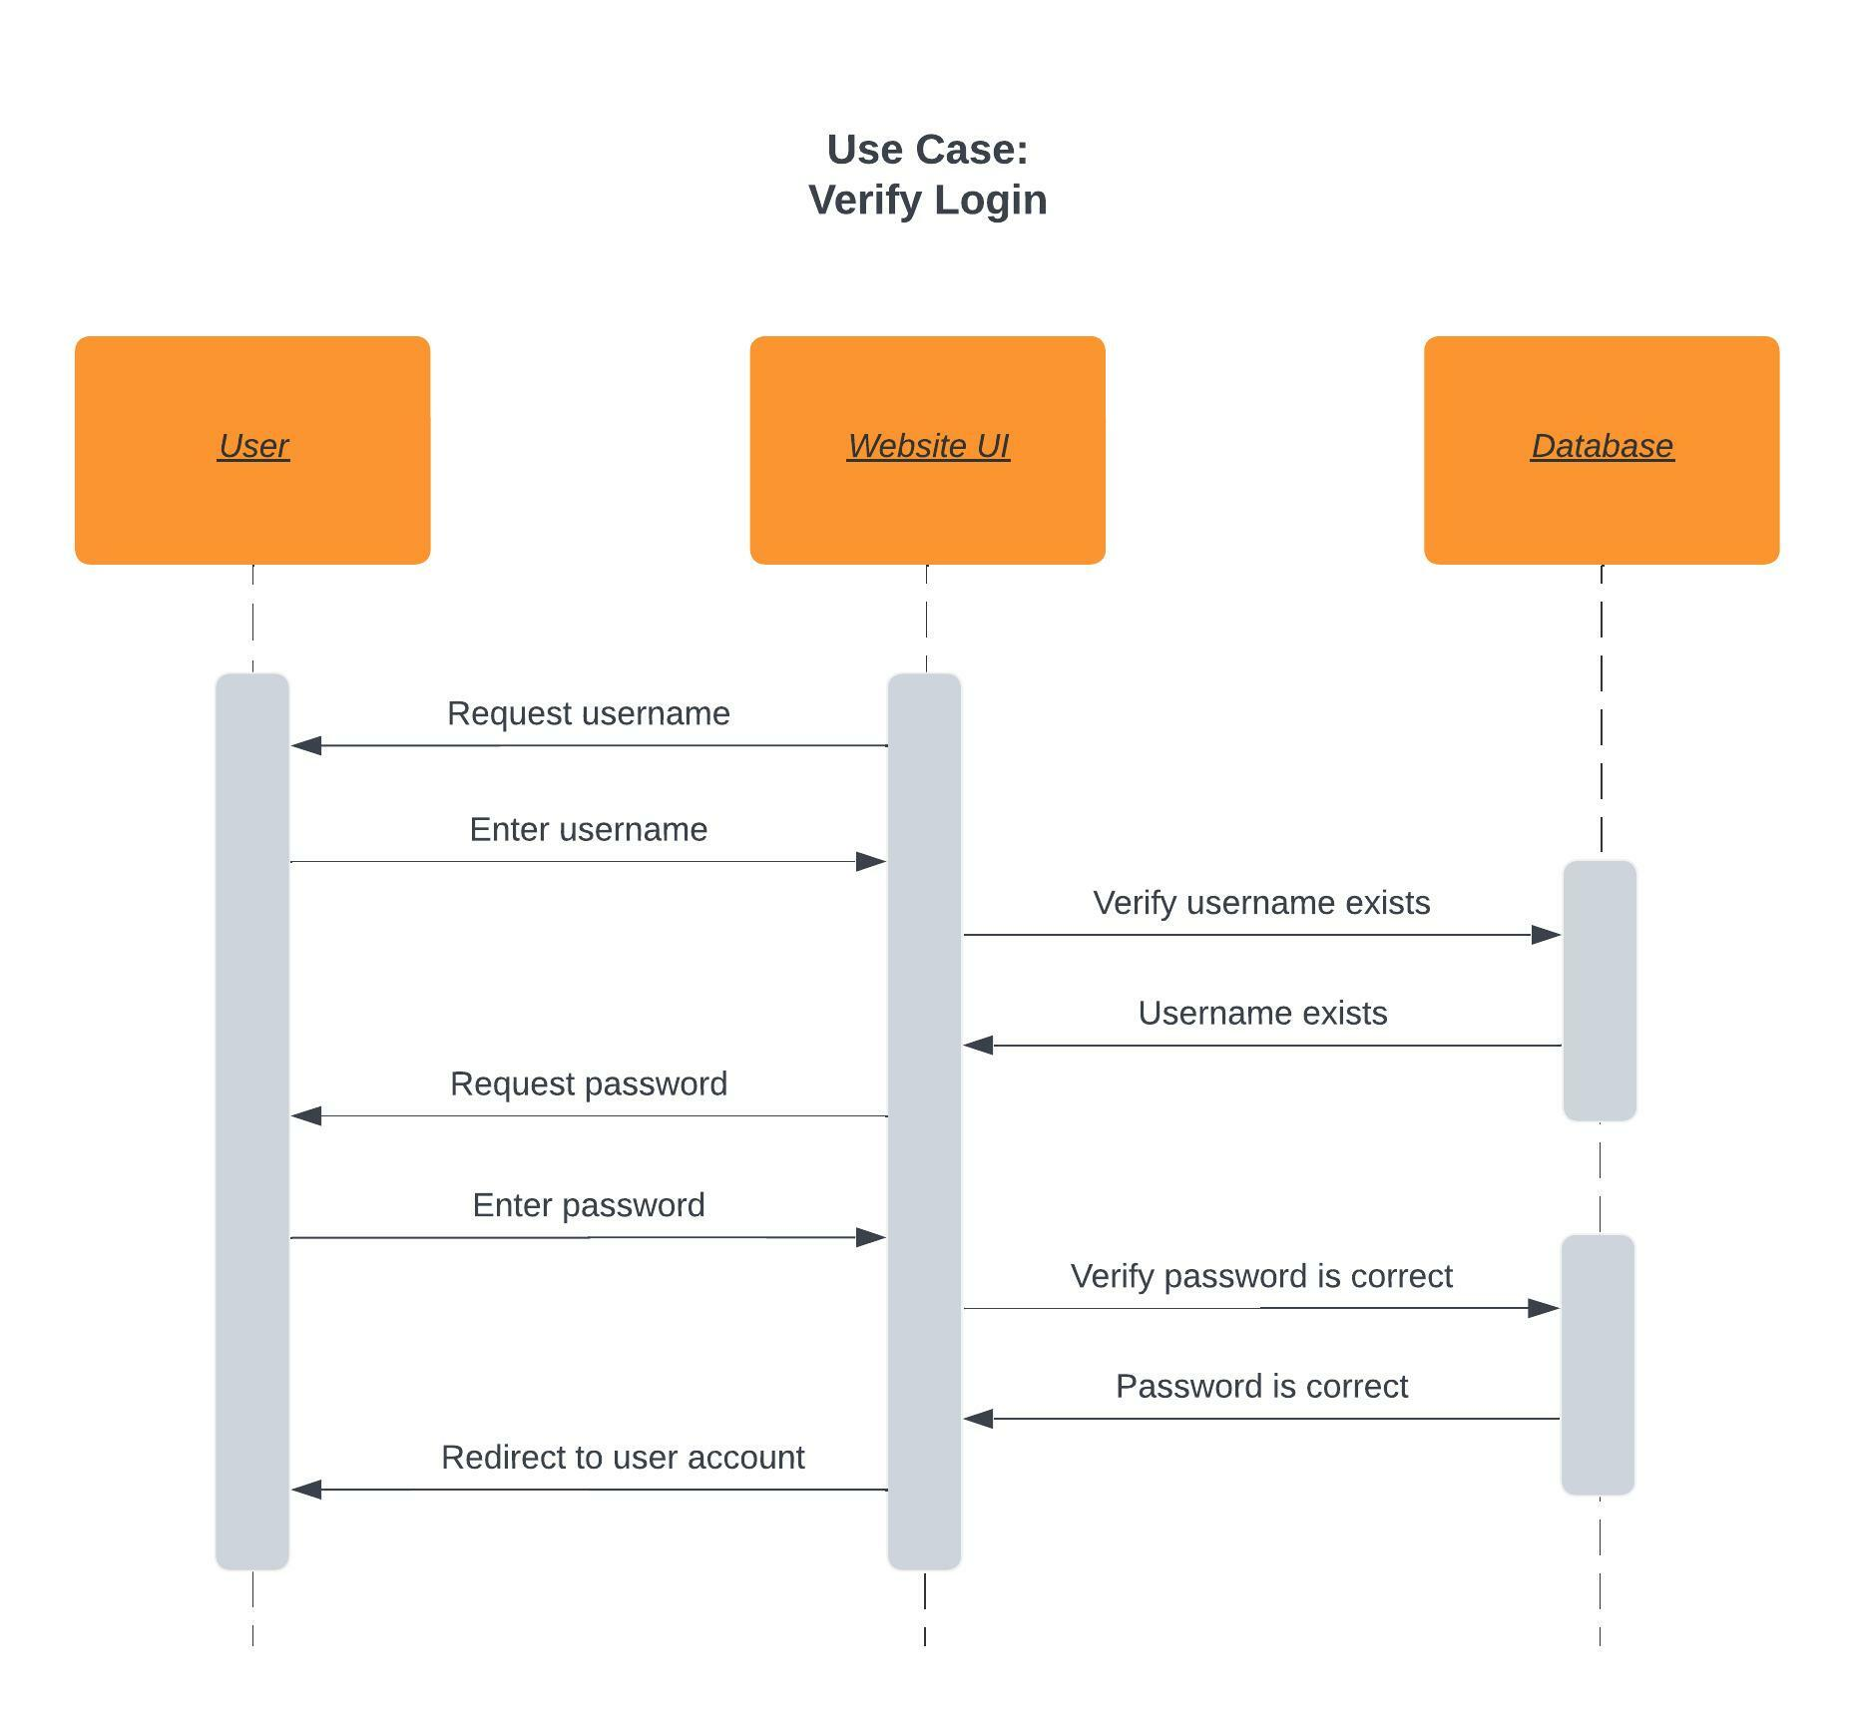

## Technical Requirements

The system being designed is web-based and must perform well even on low-end hardware. It is designed for desktops and laptops primarily, but should be visually responsive to other mobile device. Signup and login procedures will redirect users to their account. Several packages will be available for purchase, with the admin being able to modify these packages. Users should be able to access learning materials when online, and have the option to download materials for when they are offline. Users should also be able to make, modify, and cancel in-person lessons. The admin will be able to grant access to employees based on their role. Lastly, this system will be hosted by cloud service providers.